Project Design Phase-II
Data Flow Diagram & User Stories
Date | 18 June 2026
Team ID | Individual
Project Name | ShopEZ – Full-Stack E-Commerce Application (MERN Stack)
Maximum Marks | 4 Marks

Data Flow Diagrams
A Data Flow Diagram (DFD) is a visual representation of the information flows within a system. It shows how data enters and leaves the system, what processes transform the data, and where data is stored. The diagram below presents the Level-1 DFD for ShopEZ, illustrating how data moves between the Customer, the Admin, the core application processes, and the underlying data stores (Products, Cart, Orders and Users).
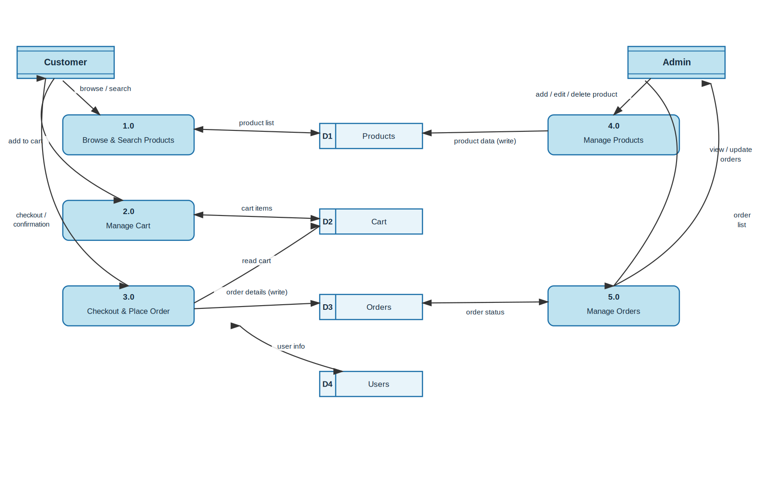
Figure 1: Level-1 Data Flow Diagram — ShopEZ E-Commerce Platform
The diagram identifies five core processes: (1.0) Browse & Search Products, (2.0) Manage Cart, (3.0) Checkout & Place Order — driven by the Customer; and (4.0) Manage Products, (5.0) Manage Orders — driven by the Admin. These processes read from and write to four persistent data stores: D1 Products, D2 Cart, D3 Orders and D4 Users, all hosted on MongoDB Atlas.

User Stories
The table below lists the user stories captured for ShopEZ, organised by user type, functional epic, priority and planned release sprint.
User Type | Functional Requirement (Epic) | User Story Number | User Story / Task | Acceptance Criteria | Priority | Release
Customer | Registration | USN-1 | As a customer, I can register for the application by entering my username, email, and password. | I can submit the registration form and my account is created in the database. | High | Sprint-1
 |  | USN-2 | As a customer, I receive a success message upon registration and I am redirected to the login page. | A confirmation toast is shown and the login page loads automatically. | Medium | Sprint-1
 | Login | USN-3 | As a customer, I can log in using my registered email and password. | A valid JWT token is issued and I am redirected to the home page. | High | Sprint-1
 |  | USN-4 | As a customer, my login session persists across page refreshes. | My token is stored and I remain logged in until I log out or the token expires. | Medium | Sprint-1
 | Product Browsing | USN-5 | As a customer, I can browse all available products on the home page. | Products load in a grid with image, title and price. | High | Sprint-1
 |  | USN-6 | As a customer, I can search for products by keyword. | Matching products are filtered and displayed instantly. | Medium | Sprint-2
 |  | USN-7 | As a customer, I can view a detailed product page with images, description, price, discount and size options. | All product details load correctly on the product detail page. | High | Sprint-2
 | Cart Management | USN-8 | As a customer, I can add a product (with chosen size and quantity) to my cart. | The item appears in my cart with the correct size and quantity. | High | Sprint-2
 |  | USN-9 | As a customer, I can update the quantity of an item or remove it from my cart. | Cart totals update immediately after the change. | Medium | Sprint-2
 |  | USN-10 | As a customer, I can view my cart subtotal before proceeding to checkout. | The displayed total matches the sum of all cart items. | High | Sprint-2
 | Checkout & Orders | USN-11 | As a customer, I can enter my shipping address and choose a payment method to place an order. | An order is created in the database for each cart item and my cart is cleared. | High | Sprint-3
 |  | USN-12 | As a customer, I receive an order confirmation after successfully placing an order. | A confirmation message is shown and I am redirected to my profile/orders page. | High | Sprint-3
 |  | USN-13 | As a customer, I can view my order history and the current status of each order. | All my past orders and their status (placed/shipped/delivered) are listed in my profile. | Medium | Sprint-3
 | Profile | USN-14 | As a customer, I can view my profile information. | My username and email are displayed correctly on the profile page. | Low | Sprint-3

